Cointegration and ECM: NZDUSD and USDCAD
Method 27 / Engle-Granger on log closes / one-lag ECM / Alpari D1 full available history

Study setup
Logical pair: PX=NZDUSD , PY=USDCAD
Broker symbols: NZDUSD_i , USDCAD_i
Snapshot: 2026-11-03_majors_alpari_D1
Timeframe: D1
Matched window: 1999-01-05 to 2026-11-02 (UTC bar dates)
Matched level count n: 7190
Dropped unfinished last bar dated 2026-11-03 UTC after a tick-volume check against the prior complete day.
ECM lags of deltas: 1
Complete matched rows (Excel): NZDUSD-USDCAD_Coint_D1.xlsx
Complete matched rows (HTML table): NZDUSD-USDCAD_Coint_D1_data.html

Method carried forward
Engle-Granger cointegration works on log price levels, not returns. For each unordered pair, PX is the left leg and PY the right leg. Step one: OLS ln(PY) = alpha + beta * ln(PX) + e. Step two: statsmodels Engle-Granger coint test on (ln(PY), ln(PX)). Error-correction: delta ln(PY)_t = c + kappa * e_{t-1} + lagged delta ln(PY) and delta ln(PX) (one lag each) + u_t. Headline is the Engle-Granger p-value (lower = stronger evidence of a stationary spread) with kappa and beta reported alongside. Same-sample Pearson r of log returns is a side check only. beta is not an automatic lot-size hedge. This is not a trading signal.

Results (headline)
alpha: -0.054746
beta: -0.647638
Engle-Granger t: -2.513451
Engle-Granger p: 0.273169
5% critical value: -3.336980
ECM kappa: -0.000898
kappa t-stat: -1.1122
ECM R^2: 0.001428
spread std: 0.075152
Pearson r (returns): -0.587831

Conclusion
Engle-Granger for PY=USDCAD on PX=NZDUSD: beta=-0.6476, alpha=-0.0547, coint_t=-2.5135, p=0.2732 (5% crit=-3.3370). ECM kappa=-0.0009 (t=-1.11). Pearson r of returns = -0.5878. beta is not a lot-size hedge. Not a trading signal.

Charts
Daily closes

Engle-Granger residual spread
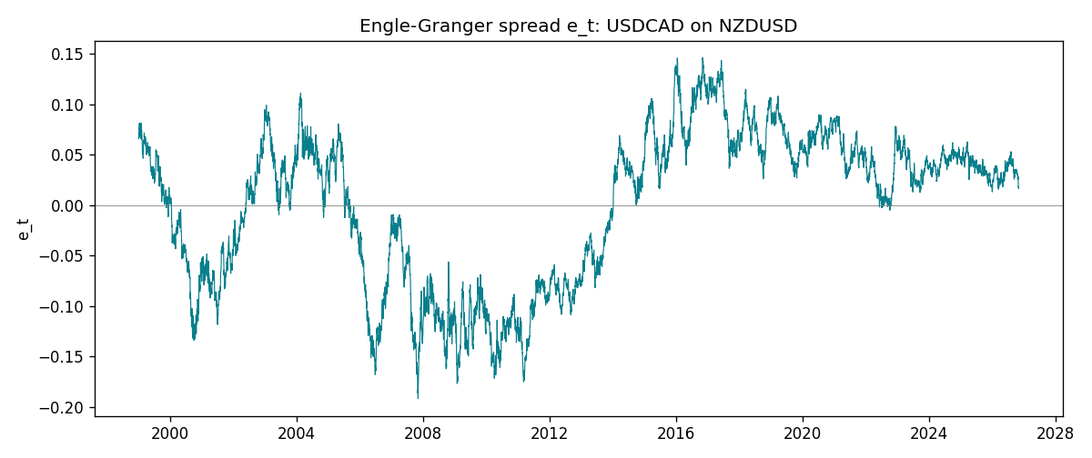
Daily log returns
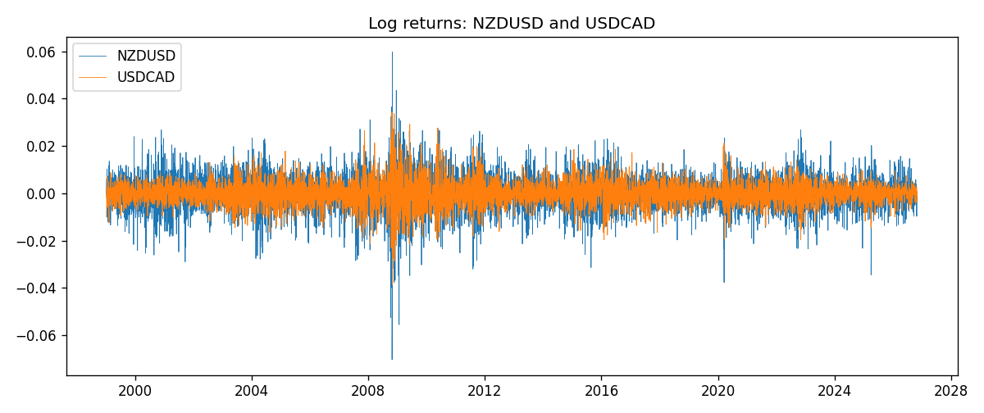

Data report
Matched rows are in the sibling Excel workbook named NZDUSD-USDCAD_Coint_D1.xlsx. Embedding all rows as a Word table is impractical; this file holds column summaries and the first and last 15 matched rows.
Column summaries
column | count | mean | std | min | 25% | 50% | 75% | max
NZDUSD_open | 7190 | 0.6563919 | 0.10821436 | 0.3913 | 0.5912925 | 0.6684 | 0.7249075 | 0.88218
USDCAD_open | 7190 | 1.2668559 | 0.16897553 | 0.9168 | 1.118445 | 1.298545 | 1.37213 | 1.6183
NZDUSD_high | 7190 | 0.66030697 | 0.10871111 | 0.3961 | 0.5947025 | 0.67202 | 0.72936 | 0.88421
USDCAD_high | 7190 | 1.2717549 | 0.16892987 | 0.9336 | 1.122975 | 1.30394 | 1.37655 | 1.619
NZDUSD_low | 7190 | 0.65270307 | 0.10781082 | 0.3897 | 0.5880525 | 0.664185 | 0.720965 | 0.87988
USDCAD_low | 7190 | 1.2623003 | 0.16901312 | 0.9056 | 1.114125 | 1.293585 | 1.36785 | 1.6102
NZDUSD_close | 7190 | 0.65646372 | 0.10821182 | 0.3907 | 0.5915625 | 0.66842 | 0.725015 | 0.8822
USDCAD_close | 7190 | 1.266877 | 0.16895077 | 0.916 | 1.118165 | 1.298615 | 1.372425 | 1.6137
NZDUSD_tick_volume | 7190 | 68672.777 | 123109.57 | 16 | 5561.25 | 33864.5 | 58508 | 1127682
USDCAD_tick_volume | 7190 | 80995.8 | 147287.89 | 37 | 5534 | 40938 | 71622.5 | 1410818
NZDUSD_spread | 7190 | 30.299444 | 25.655426 | 0 | 9 | 17 | 50 | 80
USDCAD_spread | 7190 | 23.448679 | 18.267866 | 0 | 9 | 17 | 40 | 60
NZDUSD_real_volume | 7190 | 1.6692087e+10 | 8.4955308e+10 | 0 | 0 | 0 | 0 | 2.705649e+12
USDCAD_real_volume | 7190 | 1.8371592e+10 | 9.6675129e+10 | 0 | 0 | 0 | 0 | 2.5751613e+12
NZDUSD_log_price | 7190 | -0.43564538 | 0.17593818 | -0.93981528 | -0.52498794 | -0.40283856 | -0.32156293 | -0.12533649
USDCAD_log_price | 7190 | 0.22739402 | 0.13649571 | -0.08773891 | 0.11168894 | 0.26129831 | 0.31657925 | 0.47852968
NZDUSD_log_return | 7190 | 6.02e-06 | 0.00764513 | -0.07027433 | -0.00425619 | 0.00022347 | 0.00457637 | 0.05966839
USDCAD_log_return | 7190 | -9.38e-06 | 0.0051433 | -0.03859748 | -0.00283202 | 5.381e-05 | 0.00272817 | 0.03436319
spread_e | 7190 | -0 | 0.07515184 | -0.19199861 | -0.06883062 | 0.02797059 | 0.05506146 | 0.14620975
ecm_fitted | 7189 | -7.97e-06 | 0.00019432 | -0.00119098 | -0.00012067 | -1.44e-05 | 0.00010036 | 0.00121249
First 15 matched rows (selected columns)
time | NZDUSD_log_price | USDCAD_log_price | spread_e | NZDUSD_log_return | USDCAD_log_return
1999-01-05 | -0.62138481 | 0.41363167 | 0.065945795 | -0.0018597736 | -0.010131666
1999-01-06 | -0.61933925 | 0.41330099 | 0.0669399 | 0.0020455609 | -0.0003306769
1999-01-07 | -0.61304294 | 0.4148212 | 0.072537842 | 0.0062963171 | 0.0015202092
1999-01-08 | -0.6135969 | 0.41277168 | 0.070129553 | -0.00055396548 | -0.0020495197
1999-01-11 | -0.60330648 | 0.40925791 | 0.073280243 | 0.010290425 | -0.0035137769
1999-01-12 | -0.60862223 | 0.41587738 | 0.076457036 | -0.0053157489 | 0.0066194721
1999-01-13 | -0.61859645 | 0.4204194 | 0.074539374 | -0.0099742238 | 0.0045420214
1999-01-14 | -0.6187821 | 0.42735705 | 0.081356795 | -0.00018564931 | 0.0069376546
1999-01-15 | -0.61952504 | 0.42166649 | 0.075185071 | -0.00074294208 | -0.0056905671
1999-01-18 | -0.62138481 | 0.42264993 | 0.074964057 | -0.0018597736 | 0.00098344542
1999-01-19 | -0.61952504 | 0.42539845 | 0.078917029 | 0.0018597736 | 0.002748513
1999-01-20 | -0.61544567 | 0.41943376 | 0.075594293 | 0.0040793678 | -0.0059646885
1999-01-21 | -0.61138288 | 0.41515138 | 0.073943132 | 0.0040627941 | -0.0042823796
1999-01-22 | -0.62343457 | 0.41765715 | 0.068643775 | -0.012051689 | 0.0025057712
1999-01-25 | -0.62698498 | 0.41851295 | 0.067200194 | -0.0035504102 | 0.00085579808
Last 15 matched rows (selected columns)
time | NZDUSD_log_price | USDCAD_log_price | spread_e | NZDUSD_log_return | USDCAD_log_return
2026-10-13 | -0.57755321 | 0.3516423 | 0.032343427 | 0.0047326165 | -0.0046395653
2026-10-14 | -0.58128385 | 0.35316078 | 0.031445794 | -0.0037306483 | 0.0015184751
2026-10-15 | -0.57652037 | 0.34955063 | 0.030920656 | 0.0047634855 | -0.0036101503
2026-10-16 | -0.57077027 | 0.34611842 | 0.031212431 | 0.0057501001 | -0.0034322068
2026-10-19 | -0.56887856 | 0.34423489 | 0.030554043 | 0.0018917133 | -0.0018835331
2026-10-20 | -0.56515862 | 0.34052829 | 0.029256611 | 0.0037199341 | -0.0037066008
2026-10-21 | -0.56206629 | 0.33968137 | 0.030412405 | 0.0030923331 | -0.00084691787
2026-10-22 | -0.56536981 | 0.33705064 | 0.025642192 | -0.0033035227 | -0.0026307268
2026-10-23 | -0.56227683 | 0.3370792 | 0.027673881 | 0.0030929853 | 2.85545e-05
2026-10-26 | -0.56517622 | 0.3371363 | 0.025853231 | -0.0028993932 | 5.7106554e-05
2026-10-27 | -0.56544022 | 0.33967425 | 0.028220201 | -0.00026399852 | 0.0025379458
2026-10-28 | -0.57516861 | 0.33583632 | 0.018081801 | -0.0097283914 | -0.0038379274
2026-10-29 | -0.5745467 | 0.33572196 | 0.018370207 | 0.00062190714 | -0.00011436495
2026-10-30 | -0.57435132 | 0.33469208 | 0.017466866 | 0.00019537668 | -0.0010298736
2026-11-02 | -0.57694762 | 0.33530727 | 0.016400598 | -0.0025962955 | 0.00061519094

